

**Lab Manual- Azure Voting App ( Docker Compose)**

**Prepared for**:

**Date:** 18th Dec 2023

**Prepared by:**

Document Name: Lab Manual **Document Number** AZLabn911

**Contributor:**

Contents

1. Objective 2

2. Pull the Project from GitHub 3

3. Run docker compose 3

# Objective

This sample creates a multi-container application. The Azure Vote sample app is a 2 container application. This sample shows how to run two containers in the same Container App.

* The front end container is written in python
* The back end is a standard Redis container image

# Pull the Project from GitHub

* **Step1:** Use the following command to clone the git repo

git clone https://github.com/Azure-Samples/azure-voting-app-redis.git

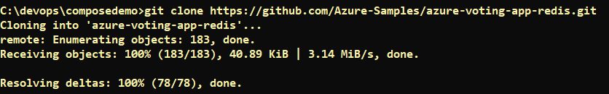

# Run docker compose GitHub

* **Step2:** Go inside the cloned git repo

C:\devops\composedemo>cd azure-voting-app-redis

* **Step3:** Run the docker compose

C:\devops\composedemo\azure-voting-app-redis> docker-compose up -d

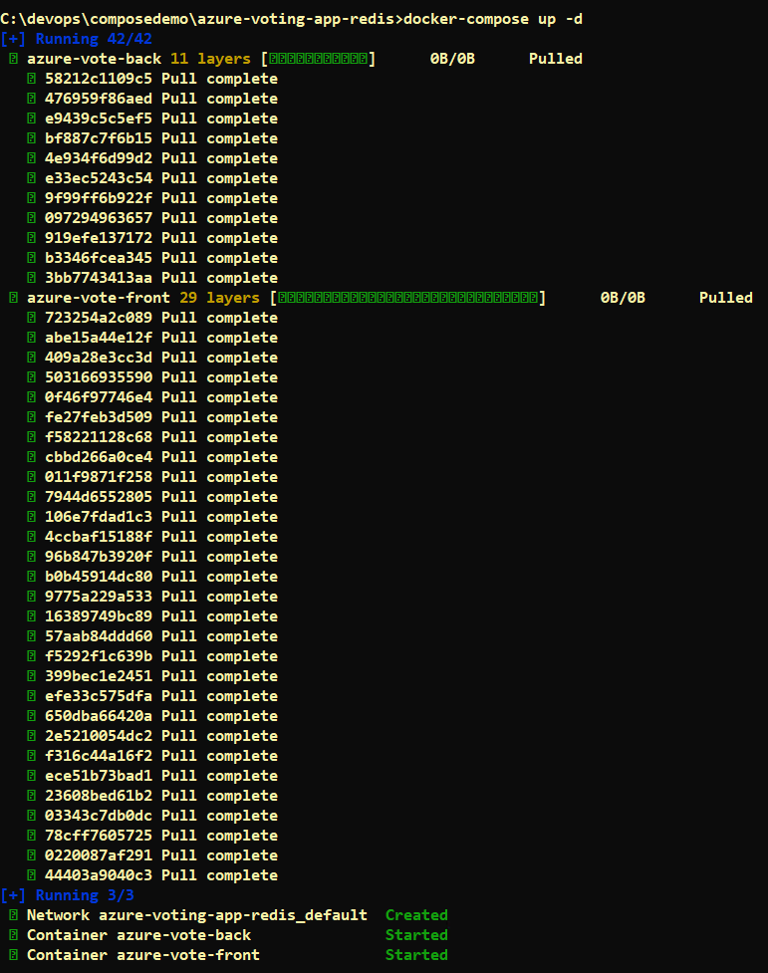

* **Step3:** Open Browser and type below URL

<http://localhost:8080/>

